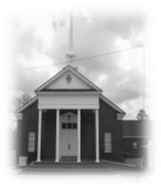
JERUSALEM MISSIONARY BAPTIST CHURCH
Post Office Box 914 – Pembroke, Georgia 31321
Rev. Victor C. Brewton, Sr. Pastor
Church: 912- 653-2272 - Dial-A-Prayer: 912- 653-3000
Church Parsonage: 653-5313
Deacon Larry Garrison, Chairman Deacon James A. Jones, Vice Chairman
Sis. Nita B. Baker, Secretary Sis. V. Carolyn Fields, Assistant Secretary
Finance Secretaries: Sis. L. Renee’ Baker, Sis. Jushara Coples, Sis. Gwen Bacon-Jones
____________________________________________________________________________________________________________

__________________________________________________________________
Jerusalem Missionary Baptist Church
“Serving the Lord in Excellence”

